 Physics 11

Electrical Circuits Test

|  |  |
| --- | --- |
| Student Name |  |
| Teacher |  |

**Time allowed for this paper**

Working time for paper: 60 minutes

**To be provided by the supervisor:**

This Question/answer booklet;

Formulae and constants sheet

**To be provided by the candidate**

Standard items: Pens, pencils, eraser or correction fluid, ruler, highlighter

Special items: Drawing instruments or templates.

A **scientific** (i.e. non graphics) calculator satisfying curriculum council requirements.

**Structure of this paper**

|  |  |  |  |  |  |
| --- | --- | --- | --- | --- | --- |
| Section | Number of questions available | Suggested working time  (minutes) | Your Mark | Marks available | Percentage of test |
| Section One:  Short answer | 16 | 22 |  | 30 | 53 |
| Section Two:  Extended | 2 | 23 |  | 17 | 30 |
| Section Three  Comprehension | 1 | 10 |  | 10 | 17 |
|  |  | **Total** |  | 57 | 100 |

**Important note to candidates**

No other items may be used in this test. It is your responsibility to ensure that you do not have any unauthorised notes or other items of a non-personal nature in the test room. If you have any unauthorised material with you, hand it to the supervisor before reading any further.

**Instructions to candidates**

1. The rules for the conduct of Western Australian external examinations are detailed in the *Year 12 Information Handbook 2015. Teacher expectations in tests will be the same.*
2. Write answers in this Question/Answer Booklet.
3. To achieve full marks, clear, logical working and diagrams MUST be shown.
4. When calculating numerical answers, show your working or reasoning clearly. Give final answers to **three** significant figures and include appropriate units where applicable.

When **estimating** numerical answers, show your working or reasoning clearly. Give final answers to a maximum of **two** significant figures and include appropriate units where applicable.

1. You must be careful to confine your responses to the specific questions asked and follow any instructions that are specific to a particular question.
2. Spare pages are included at the end of this booklet. They can be used for planning your responses and/or as additional space if required to continue an answer.
   * Planning: If you use the spare pages for planning, indicate this clearly.
   * Continuing an answer: If you need to use the space to continue an answer, indicate in the original answer space where the answer is continued, i.e. give the page number. Refer to the question(s) where you are continuing your work.

**Section One: Short answers (30 marks)**

**Question 1**

1. Which of the following graphs best represents a non-ohmic conductor? (1 mark)

Answer:

I

V

V

I

V

I

I

V

A B C D

1. Why did you select this graph? (2 marks)

|  |
| --- |
|  |
|  |
|  |

**Question 2**

Explain why the metal copper is a better electrical conductor than rubber. (2 marks)

|  |
| --- |
|  |
|  |
|  |
|  |
|  |

**Question 3**

When a resistor is connected to a 9 V battery, 1.57 × 1021 electrons pass through the resistor

in a time of 90 seconds.

a) Calculate the current in the resistor. (2 marks)

b) Calculate the work done on the electrons by the battery. (2 marks)

**Question 5**

Draw the electric field around the following two different situations. (4 marks)

|  |  |
| --- | --- |
| 1. Field due to two positive charges 2. Field between charged plates |  |

**Questions** **6** **to** **9** uses the following circuit diagram showing the connections of three similar resistors (labelled 1, 2 and 3).

C

E

F

G

A

B

D



2



1



3

**6**) The direction of conventional current flow is from

Circle the correct answer: G to A B to A D to A

(1 mark)

**7**) To determine the potential difference across resistor 2, you would use the points

Circle the correct answer: A and C A and F B and C

(1 mark)

**8**) There is no potential difference between the points

Circle the correct answer: A, D and G A, B and C E, F and G

(1 mark)

**9**) Comparing the amount of current going through points A, D and G, the order from the greatest amount of current to the least is

Circle the correct answer: A, D then G G, A then D G, D then A (1 mark)

**For questions 10 – 12** consider the following diagram

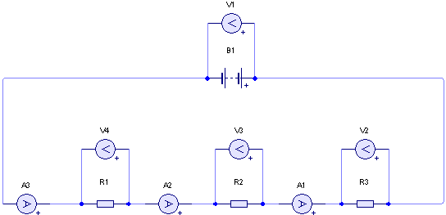

**10)** Make a statement which describes the relationship between V1, V2, V3 and V4? (1 mark )

________________________________________________________________________

**11)** Make a statement which describes the relationship between A1, A2, A3.

(1 mark )

________________________________________________________________________

**12)** If R1, R2 and R3 are all 30.0 Ω resistors, what is the total resistance of the circuit? (2marks)

**13)** A student completes a circuit that includes a mystery box as shown below.

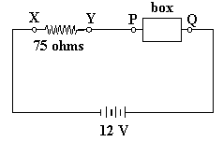

If the potential difference between X and Y is 9.0 volts, which of the following

boxes (A - D) is in the circuit? (1 mark)

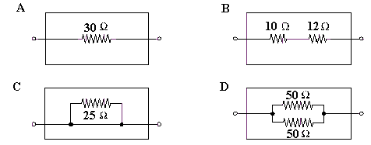

**For questions 14 – 16** consider the following diagram

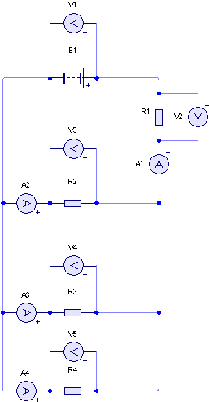

14) Make a statement(s) which describes the relationship between V1, V2, V3, V4

and V5? (1 mark )

_______________________________________________________________________

15) Make a statement which describes the relationship between A1, A2, A3 and A4. ( 1 mark )

________________________________________________________________________

16) If R1, R2, R3 and R4 are all 30.0 Ω resistors, what is the total resistance of

the circuit? (2 marks)

**Section Two: Extended answers (17marks)**

**Question 17**

**R1**

**R2**

**12 V**

**30 Ω**

**60 Ω**

1. On the circuit diagram above, show how you would connect an ammeter to measure the current through R1 and a voltmeter to measure the voltage across R1. (1 mark)
2. Calculate the current flowing in this circuit when the switch is closed. (2 marks)
3. Calculate the voltage across R1 and R2. (2 marks)

**Question 18**

**R2**

**R3**

**V**

**20 Ω**

**40 Ω**

**R1**

**R4**

**10 Ω**

**120 Ω**

**I1 = 0.3 A**

**I2**

**I3**

1. Calculate the total resistance of this circuit. (2 marks)
2. Calculate the voltage across the parallel part of the circuit. (2 marks)
3. Determine the current, I3, through R4. (1 mark)
4. Determine the current I2. (1 mark)
5. Calculate the voltage of the battery. (1 mark)

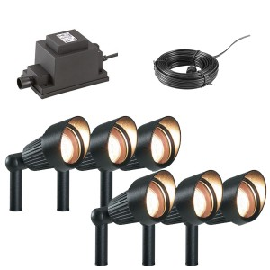**Question 19**  **(5 marks)**

A garden lighting system consists of 4(four), 13 Ω lights, connected in parallel. The system is driven by a 12 V solar panel. A safety feature of the circuit is a trip switch, which is designed to cut the power if the current in the circuit exceeds 8.00 A.

Not happy with number of lights, a home handyman wanted to connect extra lights to the system

How many lights can he have in the system without tripping the safety switch? Show all calculations required.

**Section Three: Comprehension and Interpretation (10 marks)**

**Question 19 Full Battery Electric Vehicles**

Vehicles powered by the internal combustion engine (ICE) have been in use for over a century. The operating principles of the engine are practically unchanged and they are still very inefficient. Alternative forms of propulsion are now receiving serious consideration.

Earth’s finite energy resources are being used unsustainably and urban transport plays a major role in energy wastage and pollution that contributes to climate change. The unremitting increase in oil costs and the dramatic improvement in the performance, price and lifecycle of batteries are making a compelling case for Electric Vehicles.

Hybrid vehicles recently entered the Australian market. They have both a fuel burning engine and an electric motor with a small battery that is recharged by the engine. A full battery Electric Vehicle (EV) has an electric drive system only and is powered by batteries.

The comparatively affordable technology required for Electric Vehicles is ready now. It is a solution that produces zero emissions, has the highest motor-to-wheel efficiency and requires minimal support infrastructure.

Charging socket

Electric motor

Driven wheels

Steering

Regenerative braking

Computer management system

Lithium-ion battery pack within chassis

*Schematic diagram of electric vehicle*

The main components of an Electric Vehicle are as follows

**Battery** - lithium-ion technology as used in mobile telephones and laptop computers which can provide a typical range of up to 300 km.

**Electric Motor** – drives the wheels with high torque, giving sports car like performance, but with a very low noise level and smooth delivery.

**Regenerative Braking System** - energy recovered recharges the battery.

**Computerised Management System** - controls all electrical systems to ensure optimal performance and durability of the battery. Also allows charging to be synchronised with off-peak electricity.

**Charging socket** – can be connected to a normal 240 V AC household outlet to recharge the battery in typically six to eight hours. Many councils are considering providing charging stations within cities.

Until the production volume of EVs rises significantly they will be more expensive to manufacture compared to similar sized petrol cars. Electric vehicles allow savings of up to 90% on fuel expenses and 50% on maintenance costs which makes them viable when all costs are considered.

A perceived financial risk is the lifetime and expense of the battery so some manufacturers will opt for leasing of the vehicle rather than outright purchase or leasing of the battery pack alone.

The main drawback of an EV over conventional ICE vehicles is the limited range and the time taken to recharge the battery. However, studies have shown that 99% of urban users do less than 150 km per day.

So when used as an urban vehicle that can be charged overnight, drivers should be able to adapt quickly and enjoy the benefits of this mode of transport. The EV may be the car of the future for many Australian families.

**Questions**

a. State 4 advantages of an EV over an ICE vehicle. (4 marks)

|  |
| --- |
|  |
|  |
|  |
|  |
|  |
|  |
|  |
|  |

b. Why is an EV more suited to urban driving rather than cross-country trips?(2 marks)

|  |
| --- |
|  |
|  |
|  |
|  |
|  |

1. Explain why braking is more efficient on an EV compared to a conventional ICE car by describing the energy transformations in each case. (2 marks)

|  |
| --- |
|  |
|  |
|  |
|  |
|  |

1. The computer management system controls a component in the vehicle called an inverter. This enables household electricity to be used to charge the battery and is needed because of fundamental difference between the electricity from a household socket and the electricity in a battery. What is this fundamental difference?

(2 marks)

|  |
| --- |
|  |
|  |
|  |
|  |
|  |